Exp No : 2

Date : 08/02/2019

Aim : To understand Linux commands for operations such as redirection, pipes, filters, job control, changing ownership/permissions of files/links/directory.

Command 1 : redirect

Purpose of command : redirect the output of a command from screen to a file.

Usage : command > filename.txt

Sample input and output

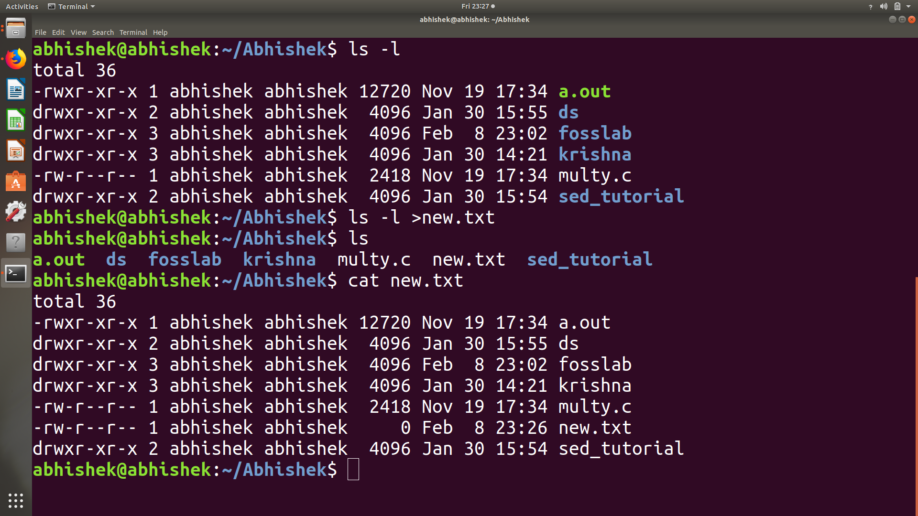

Command 2 : pipes

Purpose of command : The Pipe is a command in Linux that lets you use two or more commands such that output of one command serves as input to the next

Usage : command 1 | command 2

Sample input and output

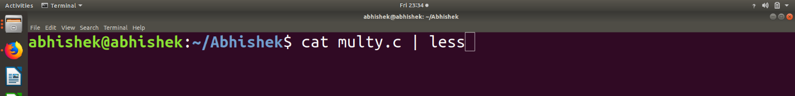

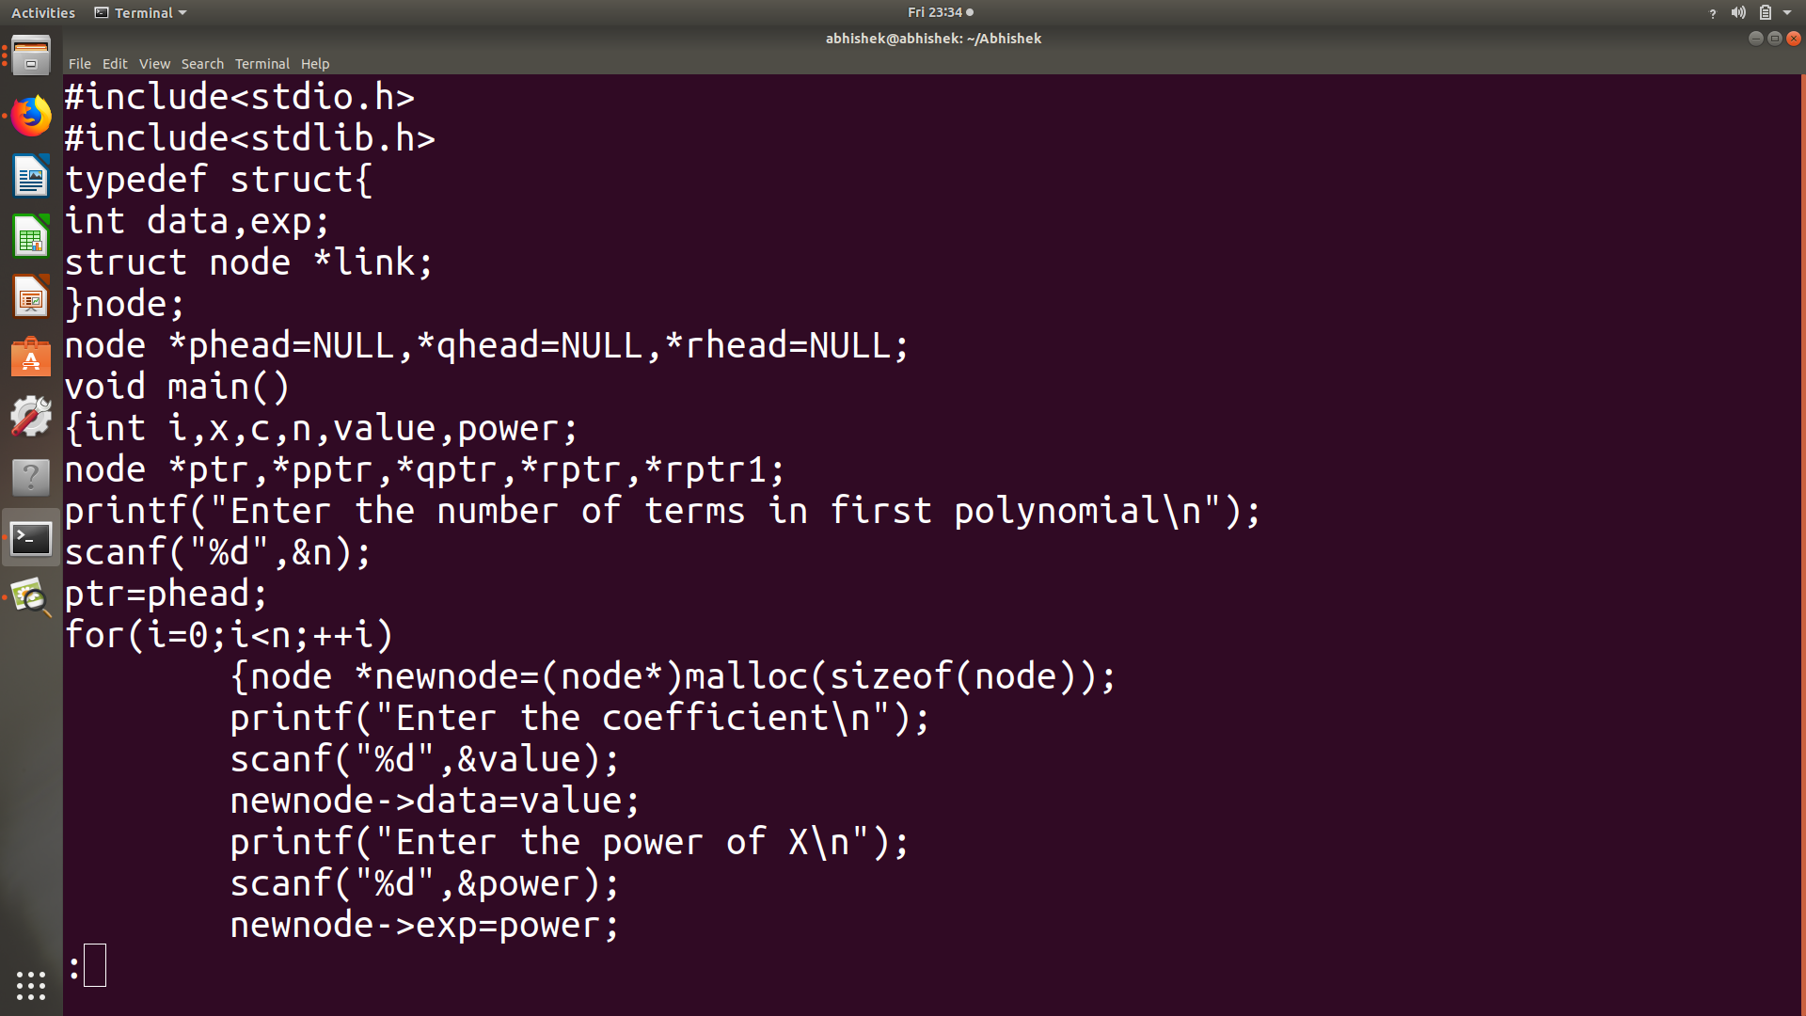

Command 3: filters

Purpose of command : A **filter** is a program that reads standard input, performs an operation upon it and writes the results to standard output.

Usage : head -n “filename” #show first n lines of a text.

tail -n “file name” #show last n lines of a text.

grep “substring” filename #shows matching pattern. etc

Sample input and output:

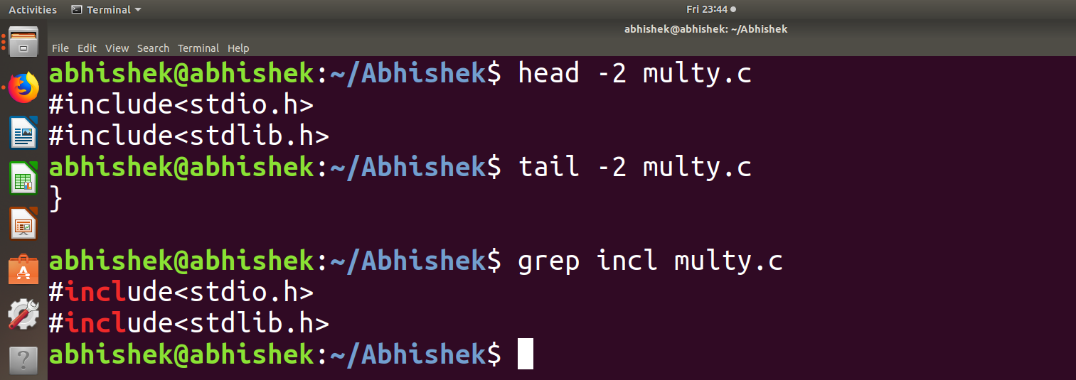

Command 4: chmod

Purpose of command : changing permission

Usage : chmod 777 “filename” #provide all permission

Chmode + or - (x,r,w) filename #add or remove permission

Sample input and output

